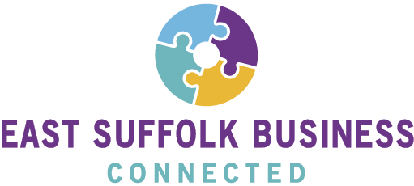

If your business was a puzzle,
do you have all the pieces?
PINCH AND A PUNCH for the first of the month! May June bring us all fresh energy and opportunities.
The first of those opportunities is here with this quick quiz from East Suffolk Business Connected (ESBC). In alignment with the work the Economic Development Team at East Suffolk Council is doing, we at ESBC aim to support East Suffolk businesses as we come out of lockdown, to the benefit of not only the county and the region but local businesses and communities too.

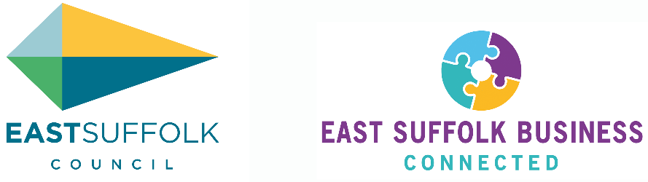

One simple question: If your business was a puzzle, do you have all the pieces?
Well, there’s only one way to find out, click the image below and take the test!
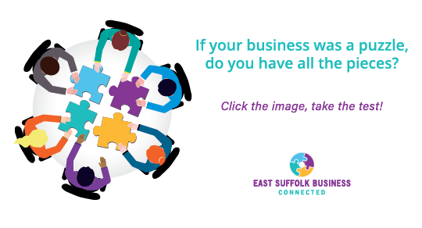
CTD overleaf / …

Of course, it’s not all a one-way street! Help us understand the needs of coastal Suffolk businesses, and you could win a scrumptious hamper of Suffolk gourmet goodies, courtesy of our friends at East of England Co-op – our thank you for your time and energy.
The closing date for replies is Friday 18th June. So be quick and CLICK HERE to take the Rapid ESBC test – something that will take the local business temperature, but definitely not get up anyone’s nose!
And if you would like to continue hearing from us, please CLICK this link to OPT-IN for future updates.
Our quiz is a bit of fun (who doesn’t need some fun right now!), but it will also help with the serious business of making coastal Suffolk THE place to do business. (Oh yes it will!)
Hoping to meet you all again soon.
Kind regards.
East Suffolk Business Connected
Formerly Heritage Coast Towns Market Initiative
and Suffolk Coast Business
Find our quick 5 minute survey at: https://eastsuffolkmeansbusiness.co.uk/esb-connected/

Follow ESB Connected on: Twitter | Facebook
East Suffolk Business Connected
A Community Interest Company
Registered office: Ensors Chartered Accountants, Blyth House, Rendham Road, Saxmundham, England, IP17 1WA | Company number: 10158106

